

**Semester One Examination 2017**

**Question/Answer Booklet**

**PHYSICS**

**UNIT 1**

**Name: _________________________________________________________________________________________**

**Teacher: ________________________________________________________________________________________**

**Time allowed for this paper**:

Reading time before commencing work: 10 minutes

Working time for paper: 3 hours

**Materials required/recommended for this paper**

***To be provides by the supervisor***

This Question/Answer Booklet

Formulae and Data Booklet

***To be provided by the candidate***

Standard items: pens, pencils (including coloured), sharpener, correction fluid, eraser, ruler, highlighters.

Special items: up to three non-programmable calculators approved for use in the WACE examinations, drawing templates, drawing compass and a protractor.

**STRUCTURE OF THIS PAPER**

|  |  |  |  |  |  |  |
| --- | --- | --- | --- | --- | --- | --- |
| Section | No. of  Questions | No. of questions  to be attempted | Suggested working time  (minutes) | | Marks available | Percentage of  exam |
| 1: Short Response | 14 | ALL | 55 | | 57 | 32% |
| 2: Problem Solving | 7 | ALL | 95 | | 94 | 53% |
| 3: Comprehension | 2 | ALL | 30 | | 26 | 15% |
| Total | **177** | **100** |

**INSTRUCTIONS TO CANDIDATES**

Write your answers in the spaces provided beneath each question. The value of each question (out of 180) is shown following each question.

The enclosed Physics: Formulae and Constants Sheet may be removed from the booklet and used as required.

Calculators satisfying conditions set by the School Curriculum and Standards Authority may be used to evaluate numerical answers. The calculator **cannot** be a “**graphics”** calculator.

Answers to questions involving calculations should be evaluated and given in decimal form. Final answers should be given up to three significant figures and include appropriate units where appropriate. Despite an incorrect final result, credit may be obtained for method and working providing these are clearly and legibly set out.

Questions containing specific instructions to **show working** should be answered with a complete, logical, clear sequence of reasoning showing how the final answer was arrived at; correct answers which do not show working will not be awarded full marks.

Questions containing the instruction "**ESTIMATE**" may give insufficient numerical data for their solution. Show your working or reasoning clearly. Give final answers to a maximum of two significant figures and include appropriate units where applicable.

**Section One: Short Response 32% (57 marks)**

This section has 14 questions. Answer **all** questions. Answer the questions in the spaces provided.

Suggested working time: 50 minutes.

**Question 1 (5 marks)**

1. Draw a **labelled** diagram of a Helium atom, ${}_{2}^{4}{He}$ (not to scale). (2 marks)
2. In the nucleus of an atom many positively charged protons are packed closely together. Explain why the protons in the nucleus don’t fly apart due to electrostatic repulsion. (3 marks)

**Question 2 (4 marks)**

Dogs don’t sweat like humans do, after exercising they pant to cool down. When dogs pant they stick out their wet tongue and blow air over it. Explain how the action of panting helps the dog cool down.

**Question 3 (7 marks)**

Two incandescent light bulbs are connected in parallel to a household 240.0 V power source. One light bulb is rated as 60.0 W and the second light bulb is rated as 80.0 W.

1. Calculate which light bulb draws the most current. (2 mark)
2. The light bulbs are then placed in a series circuit. Calculate the current through each light bulb.

(5 marks)

**Question 4 (4 marks)**

A doctor of mass 75.0 kg is taking images of a patient using a beta radiation source. If the radioisotope delivers 8.10 × 10-2 J of energy, calculate the equivalent dose the doctor receives.

**Question 5 (4 marks)**

A 3.85 V battery is used to power a smart phone. The smart phone draws a current of 21.1 mA when watching videos. Calculate how much electrical potential energy is consumed while watching a 5.00 minute video clip.

**Question 6 (5 marks)**

Computers get very hot after being used for a long time, so they often contain fans which move air through the computer case. The fan draws air in through the front of the computer case and blows it out through the back.

1. Describe how moving air through the case keeps the computer electronics cool. (3 marks)

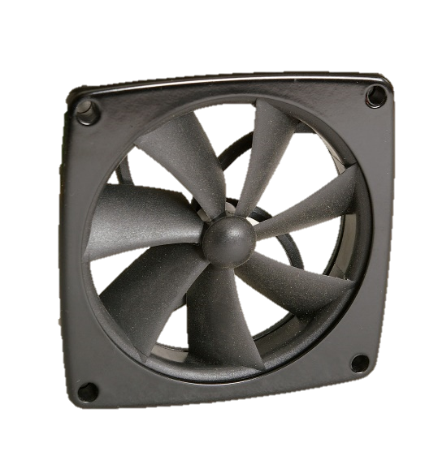

1. Some computers are water-cooled. They pump cold water through pipes positioned alongside components to keep the computer cool. Which system (air cooling or water cooling) would be the most effective at keeping the computer cool? Explain the reasoning behind your answer. (2 marks)

**Question 7 (4 marks)**

Complete the following nuclear decay equations:

1. ${}_{}^{240}{Pu}→ {}_{}^{240}{Pu}+$ (1 mark)
2. ${}_{11}^{24}{}→{}_{}^{24}{Mg}+$ (1 mark)
3. ${}_{89}^{221}{}→{}_{}^{217}{Fr}+$ (1 mark)
4. ${}_{84}^{210}{Po}→{}_{}^{4}{He}+$ (1 mark)

**Question 8 (4 marks)**

The cups shown below are used to hold hot drinks, such as tea or coffee.

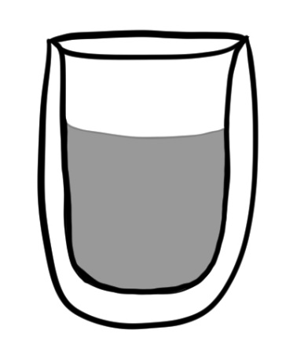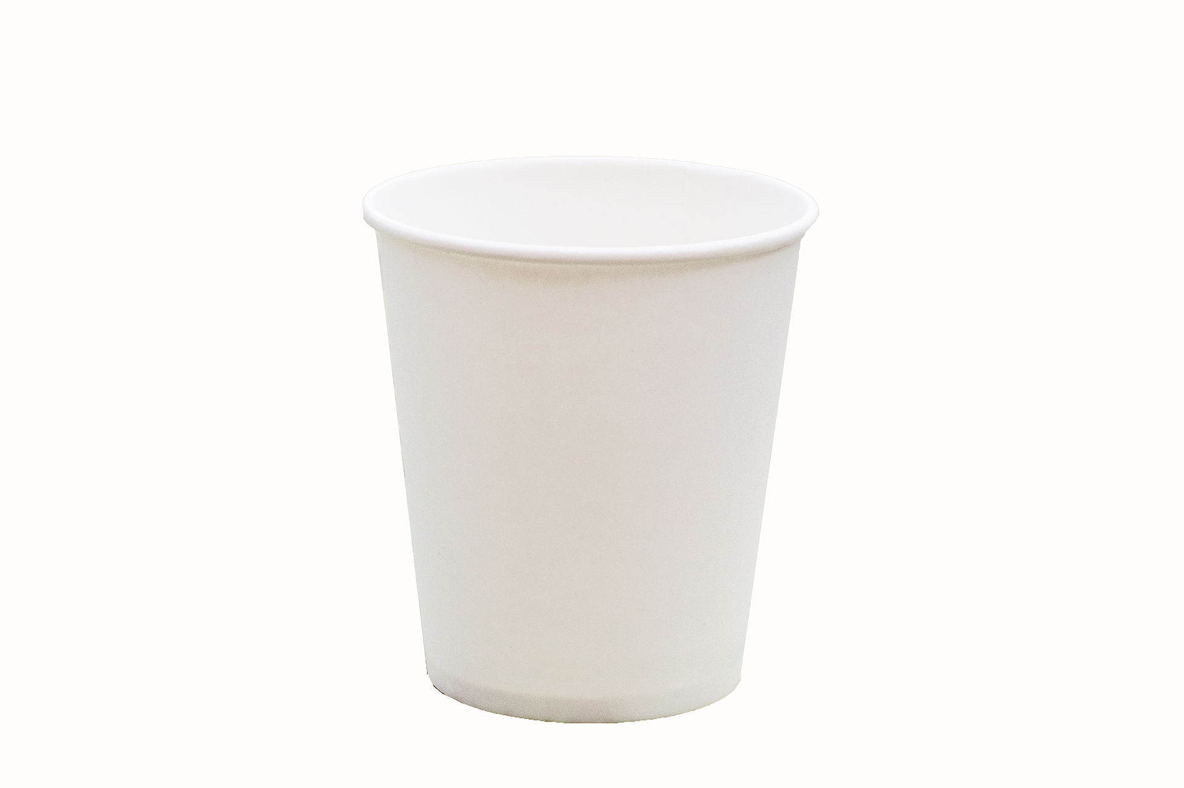

Glass

Layer of air

*Paper cup*

*Glass double-wall cup*

1. Which cup is better at preventing your hand from getting burnt? (1 mark)
2. Explain why your chosen cup from part a) is more effective at preventing burns. (3 marks)

**Question 9 (3 marks)**

Draw a **labelled** circuit diagram of a parallel circuit containing a battery, two light bulbs and a switch. Arrange the components so that when the switch is closed both lights are on, but when the switch is open only one light is on.

**Question 10 (4 marks)**

An electric kettle with a rating of 300.0 W takes 2.50 mins to heat water from 25.0 °C to 70.0 °C. Calculate how much water was in the kettle. (Assume the transfer of energy is 100% efficient).

**Question 11 (3 marks)**

The ratio of neutrons (N) to protons (Z) can be used to calculate the stability of a nucleus.

For light elements with an atomic number less than 20, stable isotopes should have a N:Z ratio of 1:1 .

1. Find the N:Z ratio for the ${}_{8}^{12}O$ isotope and determine if it is a stable isotope. (2 marks)
2. Describe what happens to an isotope if it is unstable. (1 mark)

**Question 12 (3 marks)**

1. Name one safety feature used in modern households to prevent electrical shocks (1 mark)
2. Describe how the safety feature you named in part a) works (2 marks)

**Question 13 (3 marks)**

There are $9.00×{10}^{18}$ atoms in a sample of a radioactive element. If the element has a half-life of 10.0 minutes, calculate how many atoms of this element remain after 1.00 hour.

**Question 14 (4 marks)**

A football coach has a large container holding 50 L of sports drink for his team. The sports drink starts at 35 °C and needs to be cooled down to 0 °C before half time.

Calculate how much ice (initially at -10 °C) the coach needs to add to the sports drink in order to cool it down to 0 °C. (Assume sports drink has the same properties as water and that all the ice melts).

**END OF SECTION ONE**

**Section Two: Problem-solving 53% (94 marks)**

This section contains 7 questions. Answer **all** questions. Answer the questions in the spaces provided.

Suggested working time 90 minutes.

**Question 15 (14 marks)**

Sous vide is a way of cooking food at a low temperature over a long period of time. A sous vide machine is made of a container of water with a submerged heating element (see diagram below). An electrical current passes through the heating element, warming it up which then warms the water to a constant temperature. Food (e.g. steak) is placed in sealed bags and cooks in the warm water.

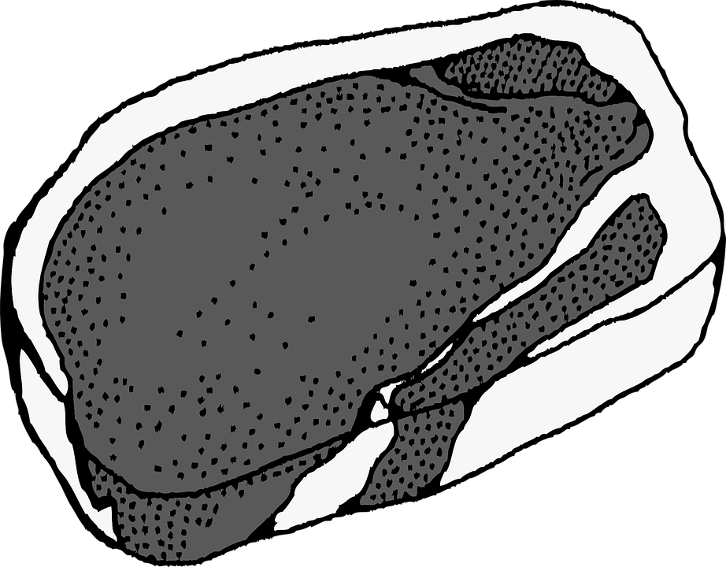

Water

Vacuum sealed bag

Steak

Heating element

Figure 1: Sous vide machine

1. A chef places 6.20 L of 28.0 °C water into a sous vide machine. The machine is rated at 2.10 kW. Calculate how long it takes the sous vide machine to heat the water up to 56.5 °C. (4 marks)
2. It actually took the sous vide machine 8.30 minutes to heat up the water from part a). Calculate the efficiency of the sous vide machine. (4 marks)
3. Some chefs are arguing over whether sous vide or pan frying is a better technique for cooking a steak. One chef argues that “in a sous vide machine the food cannot be over cooked.” Explain how this could be possible. (2 marks)
4. A 300 g steak and 250 g of carrots were taken out of the fridge at 5.00 °C. The food was added to the sous vide machine when the water was 56.5 °C. However, the sous vide machine was accidentally turned off as soon as the food was added (so no extra heat was added to the water). Calculate the final temperature of the steak and carrots. Assume no energy is lost. (4 marks)

|  |  |
| --- | --- |
| **Food** | **Specific Heat Capacity (J K-1 kg-1)** |
| Steak |  |
| Carrot | $$3.81×{10}^{3}$$ |

**Question 16 (12 marks)**

A power bank is a portable battery used to charge phones and other devices. A typical power bank can deliver 2.20 A for an hour at a voltage of 3.3 V.

1. Describe how a power bank (or battery) stores electrical potential energy which can be used to power devices. (2 marks)
2. Calculate the total amount of work the power bank is able to do before running out of energy. (4 marks)
3. Calculate the total number of electrons the power bank is able to supply. (2 marks)
4. The power bank is plugged into a mobile phone and while recharging the mobile phone draws a current of 1.32 A. Calculate how long the power bank will last until it runs out of charge. (2 marks)

1. Some students used a power meter to measure how much energy the power bank could supply and found it was $2.32×{10}^{4} J$. Calculate how efficient the power bank is. (2 marks)

**Question 17 (11 marks)**

A student conducts an experiment using an electric heater with a power rating of 3.00 kW to heat 2.50 x 102 g of ice, initially at 0.00 °C. The ice melts and after a while the resulting water begins to boil. Assume the heater transfers heat to the ice/water with 100% efficiency.

1. Calculate how much energy is required to completely melt the ice. (2 marks)
2. Calculate how long it takes to melt the ice. (2 marks)
3. The heater continues to heat the melted ice until the water begins to boil. Calculate how much energy the water needs to reach 100 °C. (2 marks)
4. Calculate how long it takes for the melted ice to reach 100 °C. (2 marks)
5. On the graph below plot what happens to the temperature (y-axis) over time (x-axis) as the ice melts and then the water begins to boil. Use data from part a) to d). (3 marks)

|  |  |  |  |  |  |  |  |  |  |  |  |  |  |  |  |  |  |
| --- | --- | --- | --- | --- | --- | --- | --- | --- | --- | --- | --- | --- | --- | --- | --- | --- | --- |
|  |  |  |  |  |  |  |  |  |  |  |  |  |  |  |  |  |  |
|  |  |  |  |  |  |  |  |  |  |  |  |  |  |  |  |  |  |
|  |  |  |  |  |  |  |  |  |  |  |  |  |  |  |  |  |  |
|  |  |  |  |  |  |  |  |  |  |  |  |  |  |  |  |  |  |
|  |  |  |  |  |  |  |  |  |  |  |  |  |  |  |  |  |  |
|  |  |  |  |  |  |  |  |  |  |  |  |  |  |  |  |  |  |
|  |  |  |  |  |  |  |  |  |  |  |  |  |  |  |  |  |  |
|  |  |  |  |  |  |  |  |  |  |  |  |  |  |  |  |  |  |
|  |  |  |  |  |  |  |  |  |  |  |  |  |  |  |  |  |  |
|  |  |  |  |  |  |  |  |  |  |  |  |  |  |  |  |  |  |
|  |  |  |  |  |  |  |  |  |  |  |  |  |  |  |  |  |  |
|  |  |  |  |  |  |  |  |  |  |  |  |  |  |  |  |  |  |
|  |  |  |  |  |  |  |  |  |  |  |  |  |  |  |  |  |  |
|  |  |  |  |  |  |  |  |  |  |  |  |  |  |  |  |  |  |
|  |  |  |  |  |  |  |  |  |  |  |  |  |  |  |  |  |  |
|  |  |  |  |  |  |  |  |  |  |  |  |  |  |  |  |  |  |
|  |  |  |  |  |  |  |  |  |  |  |  |  |  |  |  |  |  |

**Question 18 (13 marks)**

Two physics students conducted an experiment to measure the resistance of a resistor. Their results are shown in the table below.

*Table 1: Student’s results table*

|  |  |
| --- | --- |
| **Voltage (V)** | **Current (mA)** |
| 4 | 29 |
| 6 | 44 |
| 8 | 58 |
| 11 | 82 |
| 12 | 88 |

1. Graph the students’ results on the grid below. (4 marks)

|  |  |  |  |  |  |  |  |  |  |  |  |  |  |  |  |  |  |
| --- | --- | --- | --- | --- | --- | --- | --- | --- | --- | --- | --- | --- | --- | --- | --- | --- | --- |
|  |  |  |  |  |  |  |  |  |  |  |  |  |  |  |  |  |  |
|  |  |  |  |  |  |  |  |  |  |  |  |  |  |  |  |  |  |
|  |  |  |  |  |  |  |  |  |  |  |  |  |  |  |  |  |  |
|  |  |  |  |  |  |  |  |  |  |  |  |  |  |  |  |  |  |
|  |  |  |  |  |  |  |  |  |  |  |  |  |  |  |  |  |  |
|  |  |  |  |  |  |  |  |  |  |  |  |  |  |  |  |  |  |
|  |  |  |  |  |  |  |  |  |  |  |  |  |  |  |  |  |  |
|  |  |  |  |  |  |  |  |  |  |  |  |  |  |  |  |  |  |
|  |  |  |  |  |  |  |  |  |  |  |  |  |  |  |  |  |  |
|  |  |  |  |  |  |  |  |  |  |  |  |  |  |  |  |  |  |
|  |  |  |  |  |  |  |  |  |  |  |  |  |  |  |  |  |  |
|  |  |  |  |  |  |  |  |  |  |  |  |  |  |  |  |  |  |
|  |  |  |  |  |  |  |  |  |  |  |  |  |  |  |  |  |  |
|  |  |  |  |  |  |  |  |  |  |  |  |  |  |  |  |  |  |
|  |  |  |  |  |  |  |  |  |  |  |  |  |  |  |  |  |  |
|  |  |  |  |  |  |  |  |  |  |  |  |  |  |  |  |  |  |
|  |  |  |  |  |  |  |  |  |  |  |  |  |  |  |  |  |  |

1. Draw a line of best fit on the graph above. (1 mark)
2. Using the data given above and your graph, calculate the experimental value for the resistance for the resistor. (3 marks)
3. The students read the colour coding on the resistor, finding the accepted value of the resistor is 130 Ω ± 2%.

Calculate the percentage difference between the experimental value you calculated in part c) and the accepted value. Comment on whether your experimental result is within the accepted range or not.

(3 marks)

1. Describe one way the students could reduce the uncertainty in their initial measurements. (2 marks)

**Question 19 (17 marks)**

Nuclear reactors use fission reactions to generate electricity. In the nuclear reactor shown in Figure 2 the energy generated by fission heats up the water, the water boils creating steam which turns a turbine creating electricity.

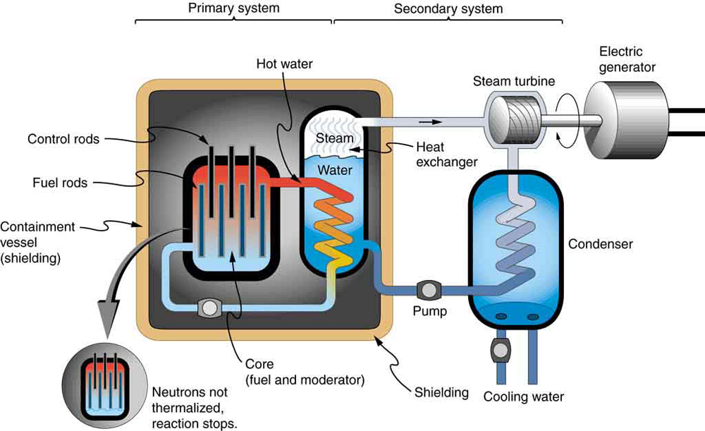

Figure 2: Pressurised water nuclear reactor diagram

The nuclear reactor shown above uses Uranium-238 as a fuel source. The Uranium undergoes fission according to the following equation:

$${}_{0}^{1}n+{}_{92}^{238}U→{}_{38}^{96}{Sr}+{}_{54}^{140}{Xe} + ?{}_{0}^{1}n$$

1. How many neutrons are released as a product of this fission reaction? (1 mark)
2. Calculate the energy (in electron volts) released by the fission reaction shown in part a). (4 marks)

|  |  |
| --- | --- |
| **Element** | **Mass (u)** |
| Uranium-238 | 238.050784 |
| Strontium-38 | 95.921750 |
| Xenon-140 | 139.92164 |
| Neutron | 1.008665 |

1. Name and describe two safety features used in nuclear reactors. (4 marks)
2. Explain why it is easier for a neutron to enter the nucleus compared to an alpha particle or a proton. (3 marks)
3. The electrical power output of the nuclear reactor facility is 901 MW. Calculate the mass of Uranium-235 fissioned in one year of full-power operation. (5 marks)

**Question 20 (14 marks)**

A circuit consisting of a 9.00 V power source and four resistors is shown below. When the switch is open the total current in the circuit is 0.96 A.

9.00 V

3.15 Ω

X

2.00 Ω

4.00 Ω

1. Calculate the resistance value of the resistor labelled X. (4 marks)
2. Calculate the total amount of power used by the circuit when the switch is open. (2 marks)
3. Calculate the total resistance of the circuit when the switch is closed. (6 marks)

1. Calculate the total current in the circuit when the switch is closed. (2 marks)

**Question 21 (13 marks)**

Nuclear fusion takes place inside stars to produce large amounts of energy. Our Sun undergoes a series of steps called the proton-proton cycle. This process releases a tremendous amount of energy.

|  |  |
| --- | --- |
| **Element** | **Mass (kg)** |
| Helium-4 | 6.6443 x 10-27 |
| Hydrogen | 1.6732 x 10-27 |
| Helium-3 | 5.0066 x 10-27 |

1. Write the nuclear equation for the middle step of the proton-proton cycle, where a deuterium atom (Hydrogen-2) and a Hydrogen atom fuse to form a Helium-3 atom and gamma radiation. (1 mark)
2. The final step of the proton-proton cycle is:

$${}_{2}^{3}{He}+{}_{2}^{3}{He}→{}_{2}^{4}{He}+{}_{1}^{1}H+{}_{1}^{1}H$$

Calculate how much energy (in Joules) is released by this reaction. (4 marks)

1. If the power output from the Sun is $4.00×{10}^{26} W$, calculate how many kilograms of Helium-3 is used up by the Sun each second. (4 marks)
2. Why does the nuclear fusion process release more energy per nucleon than nuclear fission? (2 marks)
3. One of the requirements for fusion to occur is extremely high temperatures in the order of ${10}^{8} K$. Describe why fusion only occurs under these circumstances. (2 marks)

**END OF SECTION TWO**

**Section Three: Comprehension 15% (26 marks)**

This section has two questions. Answer **both** questions. Answer the questions in the spaces provided.

Suggested working time: 40 minutes.

**Question 22 (14 marks)**

**Nuclear Imaging with Radioisotopes**

**Nuclear Imaging**

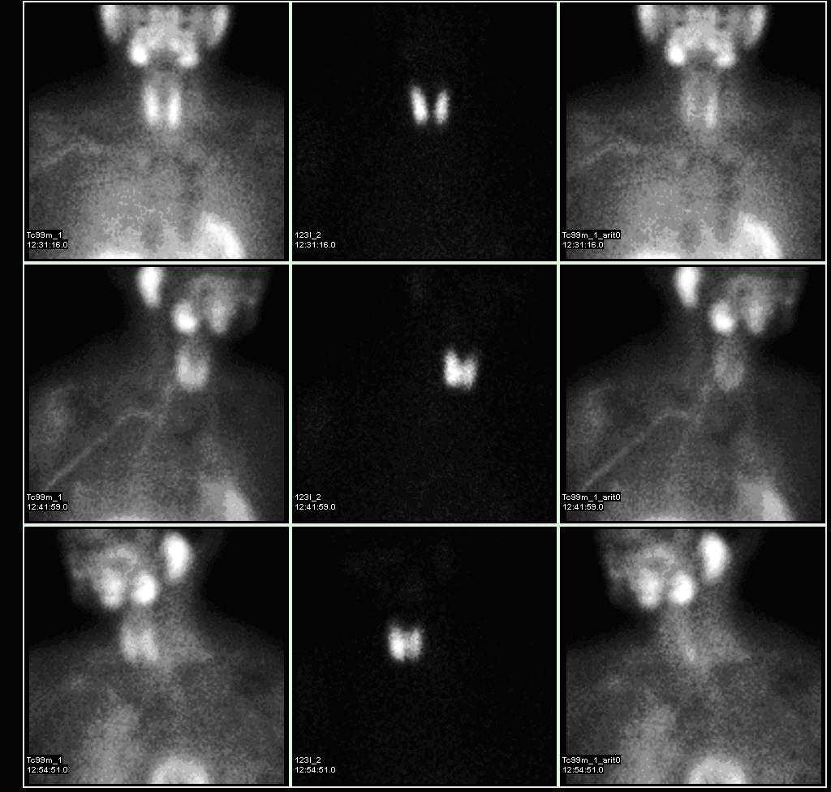Nuclear imaging is a technique that uses radioisotopes to emit radiation from within a patient’s body. A radioisotope is given to a patient either orally, by injection or it can be inhaled. Nuclear imaging can provide doctors with information that other techniques can’t. For example, X-rays can only image bone but nuclear imaging can take pictures of both bone and soft tissue. With nuclear imaging doctors can detect secondary cancer up to two years before it can be seen in a standard X-ray.

The radioisotopes used in nuclear imaging are usually gamma emitters. Doctors use a special gamma camera to detect the gamma radiation and create an image to help diagnose diseases such as cancer. Different elements are used including isotopes of technetium, gallium, iodine, xenon and thallium. The type of radioisotope used depends on which part of the body is being investigated. For example, Iodine-131 is used to take images of the thyroid.

Nuclear imaging can show the position and concentration of the radioisotope in the patient’s body. A ‘hot spot’, an area where the radioisotope has been absorbed into the tissue or organ may be due to a diseased state, such as infection or cancer.

**Iodine Radioisotopes**

Iodine radioisotopes are often used to take images of the thyroid, a gland in your neck. Iodine-131 is not used often due to the danger it can pose to the patients’ health. Other less-damaging radioisotopes such as Iodine-123 are preferred in most situations.

Iodine-131 contributed to the health problems experienced after the Chernobyl nuclear power plant meltdown. It was also spread through the air after the Fukushima nuclear crisis.

|  |  |  |
| --- | --- | --- |
|  | **Iodine-123** | **Iodine-131** |
| **Decays by:** | 100% Gamma | 90% Beta, 10% Gamma |
| **Half-life:** | 13.22 hours | 8.02 days |

**Figure 3:** Nuclear images of a patient’s head and chest. The thyroid (circled in the third image) appears as a ‘hot spot’.

1. State the key difference between nuclear imaging and other imaging techniques. (1 mark)
2. Name two elements used in nuclear imaging. (1 mark)
3. Explain why nuclear imaging usually uses gamma radiation (instead of alpha or beta radiation). (3 marks)
4. Explain why Iodine-123 is used more often in nuclear imaging than Iodine-131. (3 marks)
5. Iodine-131 is created by Tellurium-130 absorbing a neutron, the Tellurium then beta-decays into Iodine-131. Write the nuclear equations for the creation of Iodine-131

(2 marks)

1. Draw a graph of ‘fraction of sample remaining’ against ‘time’ for Iodine-123. (4 marks)

|  |  |  |  |  |  |  |  |  |  |  |  |  |  |  |  |  |  |
| --- | --- | --- | --- | --- | --- | --- | --- | --- | --- | --- | --- | --- | --- | --- | --- | --- | --- |
|  |  |  |  |  |  |  |  |  |  |  |  |  |  |  |  |  |  |
|  |  |  |  |  |  |  |  |  |  |  |  |  |  |  |  |  |  |
|  |  |  |  |  |  |  |  |  |  |  |  |  |  |  |  |  |  |
|  |  |  |  |  |  |  |  |  |  |  |  |  |  |  |  |  |  |
|  |  |  |  |  |  |  |  |  |  |  |  |  |  |  |  |  |  |
|  |  |  |  |  |  |  |  |  |  |  |  |  |  |  |  |  |  |
|  |  |  |  |  |  |  |  |  |  |  |  |  |  |  |  |  |  |
|  |  |  |  |  |  |  |  |  |  |  |  |  |  |  |  |  |  |
|  |  |  |  |  |  |  |  |  |  |  |  |  |  |  |  |  |  |
|  |  |  |  |  |  |  |  |  |  |  |  |  |  |  |  |  |  |
|  |  |  |  |  |  |  |  |  |  |  |  |  |  |  |  |  |  |
|  |  |  |  |  |  |  |  |  |  |  |  |  |  |  |  |  |  |
|  |  |  |  |  |  |  |  |  |  |  |  |  |  |  |  |  |  |

**Question 23 (12 marks)**

**Staying warm in the Arctic**

Inuit people are a collection of indigenous people who live in the Arctic regions of Greenland, Canada and Alaska. In the Arctic the temperature in winter ranges from -35 °C to 0 °C, but it can drop as low as -50 °C. During the summer temperatures range from -10°C up to 10°C.

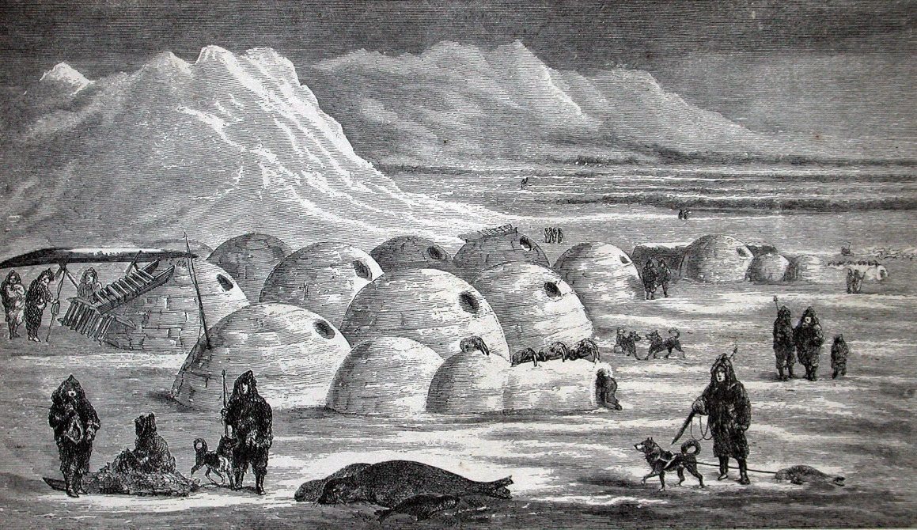

**Figure 4:** Illustration of an Inuit village

On winter hunting trips the Inuit people used to live in temporary shelters called igloos. Igloos are made from compressed snow, which is chopped into large blocks which are then stacked in a dome shape. Compressed snow is used as it contains many small air pockets inside making it a good insulator.

Inside the igloo the floor is uneven with a raised section for sleeping on (see Figure 5). The entrance area acts as a ‘cold trap’ whereas the sleeping area holds any heat generated by stoves, lamps or body heat. Inside the igloo, temperatures can range from −7 °C to 16 °C when warmed by body heat alone. Igloos also have a small ventilation hole to allow smoke from lamps to escape.

Ventilation hole

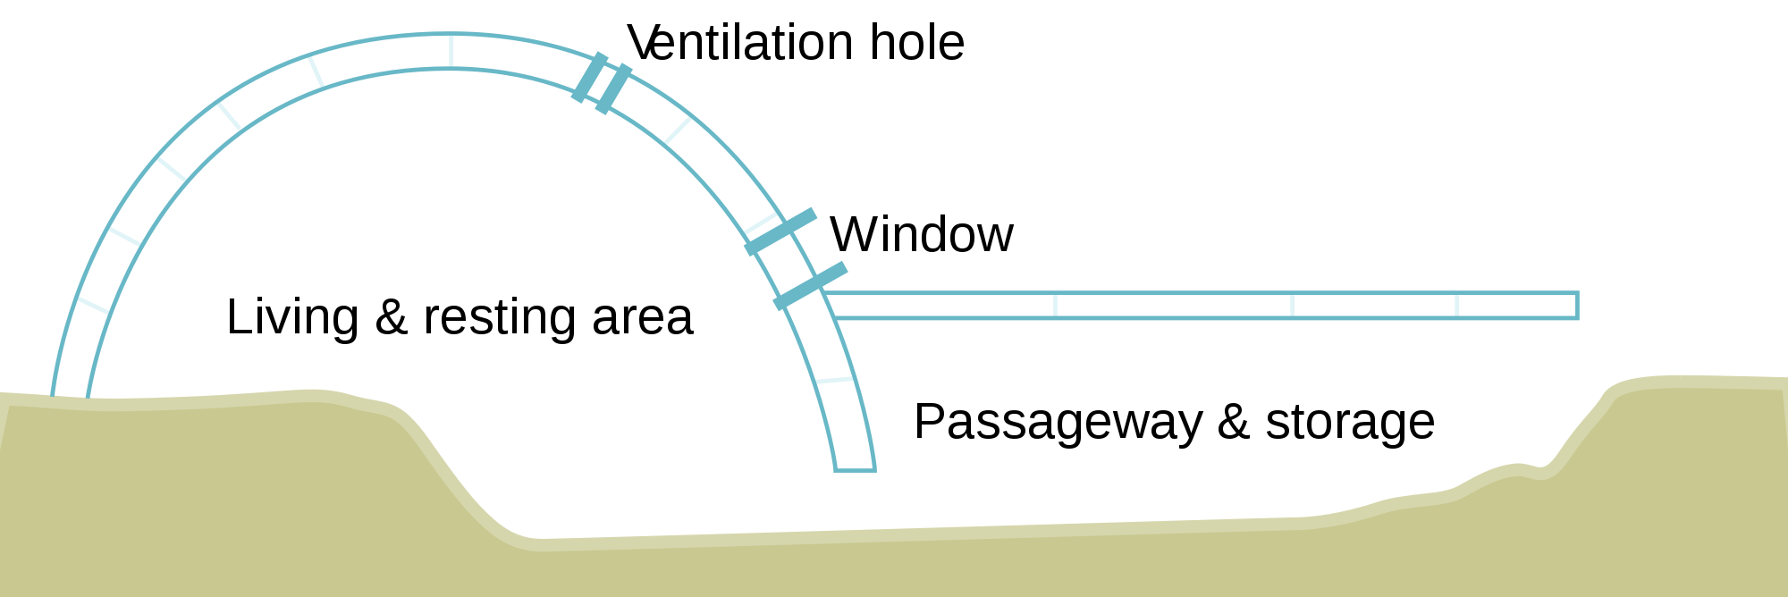

**Figure 5:** Diagram showing the inside of an igloo

1. Explain why the raised sleeping area would ‘hold any heat’ and be warmer than sleeping on the lower level. (3 marks)
2. Explain why compressed snow is a better insulator than a solid ice block. (3 marks)
3. Explain why the igloo doesn’t completely melt even when the air temperature inside the igloo is 16 °C. (2 marks)
4. Calculate the amount of energy needed to melt an entire igloo which is at -10 °C. The igloo is made of 150 blocks, each with a volume of 0.05 m3. Compressed snow has a density of $200 kg/m^{3}$. (4 marks)

**END OF SECTION THREE**

**Acknowledgements**

Rainer Knäpper. Fan. CC BY-SA 2.0. Adapted from <https://commons.wikimedia.org/wiki/File:Luefter_y.s.tech_pd1270153b-2f.jpg#mw-jump-to-license>

Augustus Binu. Paper cup. CC BY-SA 4.0. Adapted from <https://commons.wikimedia.org/wiki/File:Paper_cup_DS.jpg>

Rice University. Nuclear reactor diagram. CC BY 4.0. Adapted from <http://cnx.org/contents/Ax2o07Ul@9.39:LJeKXQqg@8/Fission>

Myo Han. Nuclear medicine parathyroid scan. CC BY 3.0. Adapted from <https://en.wikipedia.org/wiki/Sestamibi_parathyroid_scintigraphy#/media/File:Parathyroid_subtraction.jpg>

Igloo. Drawn by unknown artist based on sketches by C.F. Hall and photographed from the book by User:Finetooth - Arctic Researches and Life Among the Esquimaux: Being the Narrative of an Expedition in Search of Sir John Franklin in the Years 1860, 1861, and 1862 by Charles Francis Hall (1865), New York: Harper and Brothers., Public Domain, <https://commons.wikimedia.org/w/index.php?curid=3648025>

Igloo Diagram. By derivative work: Pbroks13 (talk)Igloo_see-through_sideview_diagram.png: - Igloo_see-through_sideview_diagram.png, CC BY-SA 3.0, <https://commons.wikimedia.org/w/index.php?curid=4379835>

WATP acknowledges the permission of School Curriculum and Assessment Authority in

providing instructions to students.